Jmeter:---
This is a tool which is used for Performance testing.

Performance testing:----Tester check how fastly and effeciently responsed on user request.
Types of Performance testing:
-Load testing
-Stress Testing

jmeter file extension is .jmx

How to do Load testing
Step 1: Open apache jmeter tool.
Step 2: Right click on Test Plan , then select Add---then select threads and then select jp@gc-Stepping thread Group(deprecate).
Note: Threads means “Users”.
Step 3: Set the parameters in stepping threads.
This group start for: 100------------------means, total 100 users are going to use this application.
First, wait for: 10-----------means, initially wait for 10 seconds and then start testing.
Then start: 10---------means, initially only 10 users are going to join the application.
Next add: 10 threads every: 10----------means, Next 10 users are going to add in 10 seconds
using Ramp-up: 3--------means, 3 users are going to join the application in 1 second.
Then hold load for: 60--------means, system hold 100 users for 60 seconds(1 min).
Finally Stop: 10 threads every: 10-------means, 10 users are going to exit from the application after every 10 seconds.
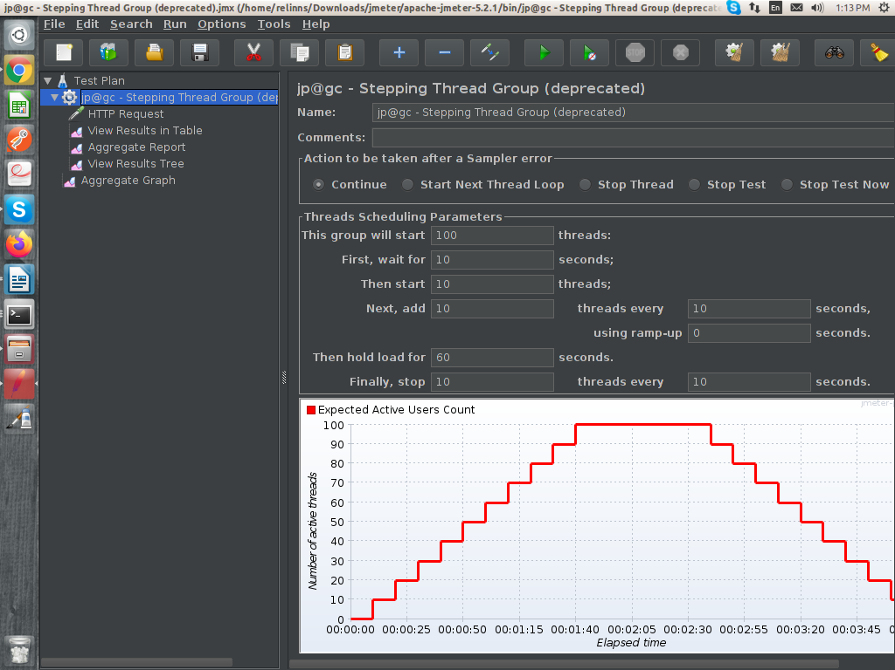
Step 4: Right click on jp@gc-Stepping thread Group, then click on Add-----then click on Sampler---and then click on HTTP Request.
Note: Sampler used for Requests.
Step 5: Fill the parameters of HTTP Request.
Server Name or IP: www.google.com
Path: /calender/
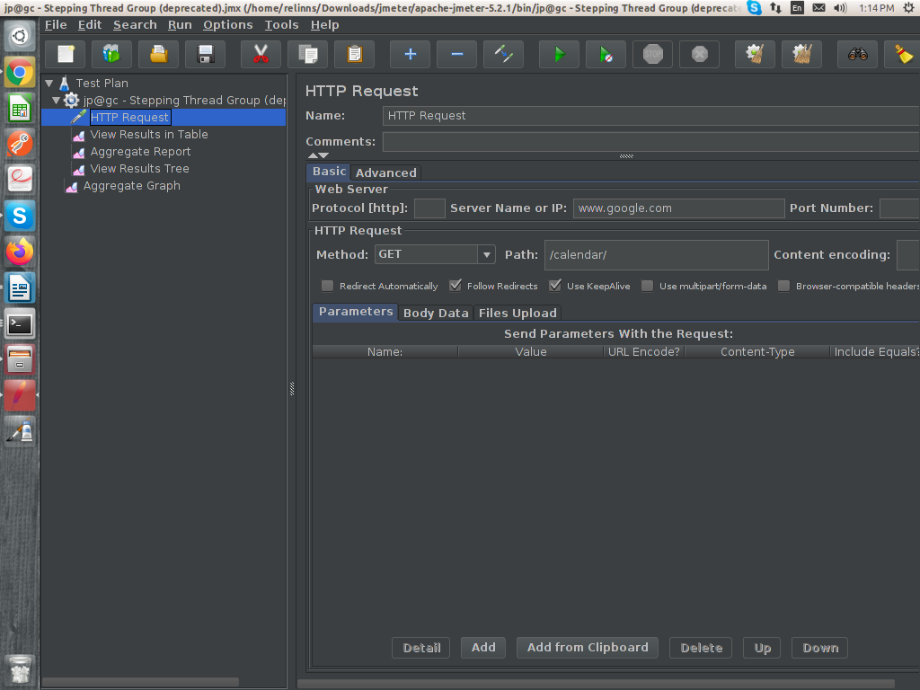

Step 6: Right click on Test Plan , then select Add---then select Listener---then select Aggreagate Report.
Note: Listener is used to shown a result. We can select any type of listener which we want.
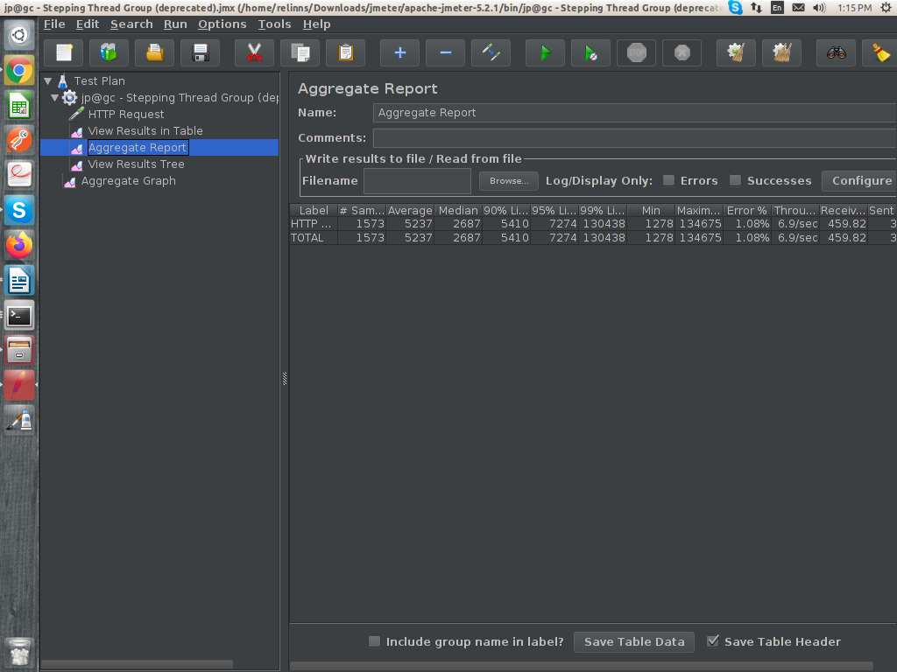
Other Components:
- Run(Ctrl+r): to run the test
- Stop: to stop the test. But, it stop the test immediately means all the iterations are stopped which are in progess like they requset for server.
- Shutdown: it also stop the test but, after completing all the iterations, those are in progress.
- Clear: Clear all the records of the current threads request.
- Clear all: Clear all the records of all the threads request.

